Internationale Lichttage Winterthur 2004


Introduction
What is the workshop?
The sites
The Underpass
The Boiler House
The Corridor
Hall 53
Tempodrom Square
Paths Through Time
English Deutsch
Hall 53
Headed by Uwe Belzner/ELDA
Participants: Mandy Langer/D, Eva-Maria Kimmerl/D, Florian Wild/D, Florian Heine/D, Xuemin Dai/RC, Marc Dentand/CH, Felix Peyer/CH, Rico Baumann/CH
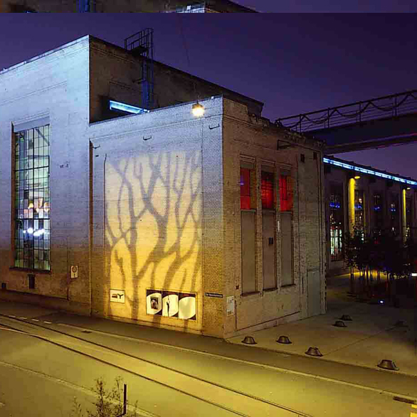
Following the theme of "point of change", the façades of Hall 53 were modelled to become a symbol for the Sulzer area as a place of constant movement and change. The existing installation on the façade running along Sulzerplatz was complemented by a subtle two-colour (green and red) installation in the interior. This moves the focus away from the large, black window surfaces and offers the viewer the reserved, calm experience of discovering constructive details in the old industrial culture. The top façade of the "Kasselschmiede" has been designed to show the area as a place of chance with the help of modern lighting technology (moving lights and LED technology). The illumination of the façade with white LEDs (the moon-light façade) is complemented by an interesting light/shadow sequence on the right-hand façade surface and also by a dynamic lighting installation on the window surface.

